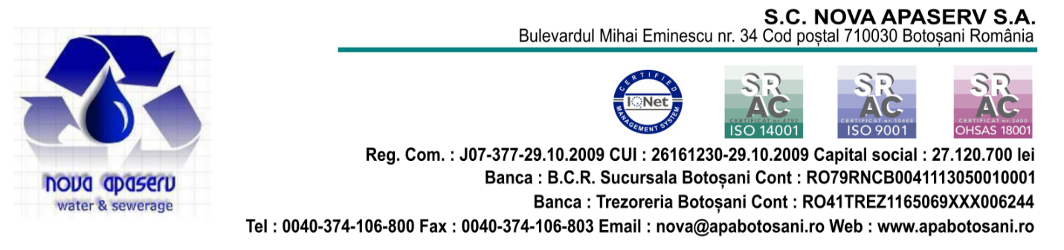
Se aprobă,
Director General,
ing. Liviu Nicolae Stefan
PROGRAM SPECIAL CASIERII SARBATORILE DE PASTI 2024
Perioada 01-07 Mai 2024
Casieria | Miercuri  01.05.2024 | Joi  02.05.2024 | Vineri  03.05.2024 | Sambata  04.05.2024 | Duminica  05.05.2024 | Luni  06.05.2024 | Marti  07.05.2024
Bulevard Botosani | 08.00-12.00 | Program normal | 08.00-12.00 | Inchis | Inchis | Inchis | 08.00 – 16.00
Primaverii Botosani | Inchis | Program normal | Inchis | Inchis | Inchis | Inchis | Inchis
Uvertura Mall | 10.00-14.00 | Program normal | 10.00-14.00 | Inchis | Inchis | Inchis | Inchis
1 Decembrie Botosani | Inchis | Program normal | Inchis | Inchis | Inchis | Inchis | Inchis
A.I.Cuza Dorohoi | 08.00-12.00 | Program normal | 08.00 -12.00 | Inchis | Inchis | Inchis | 08.00 – 16.00
Casieria Darabani | Inchis | Program normal | Inchis | Inchis | Inchis | Inchis | Inchis
Casieria Saveni | Inchis | Program normal | Inchis | Inchis | Inchis | Inchis | Inchis
Casieria Bucecea | Inchis | Program normal | Inchis | Inchis | Inchis | Inchis | Inchis

Contabil Sef, Şef Serviciu Facturare-Incasare,
ec. Daniela Jîtaraşu ec. Maria Bolea

